|  |  |
| --- | --- |
| **Project Case** |  |
| COMP6583001  Computer Graphics |
| **Computer Science** | **O222-COMP6583-HS01-00** |
| ***Valid on*** *Odd Semester Year 2021/2022* | **Revision 00** |

1. Seluruh kelompok tidak diperkenankan untuk:

*The whole group is not allowed to:*

* + - Melihat sebagian atau seluruh proyek kelompok lain,

*Seeing a part or the whole project from another groups*

* + - Menyadur sebagian maupun seluruh proyek dari buku,

*Adapted a part or the whole project from the book*

* + - Mendownload sebagian maupun seluruh proyek dari internet,

*Downloading a part or the whole project from the internet,*

* + - Mengerjakan soal yang tidak sesuai dengan tema yang ada di soal proyek,

*Working with another theme which is not in accordance with the existing theme in the matter of the project,*

* + - Melakukan tindakan kecurangan lainnya,

*Committing other dishonest actions,*

* + - Secara sengaja maupun tidak sengaja melakukan segala tindakan kelalaian yang menyebabkan hasil karyanya berhasil dicontek oleh orang lain / kelompok lain.

*Accidentally or intentionally conduct any failure action that cause the results of the project was copied by someone else / other groups.*

1. Jika kelompok terbukti melakukan tindakan seperti yang dijelaskan butir 1 di atas, maka **nilai kelompok** yang melakukan kecurangan (menyontek maupun dicontek) akan di – **NOL** – kan.

*If the group is proved to the actions described in point 1 above, the score of the group which committed dishonest acts (cheating or being cheated) will be “Zero”*

1. Perhatikan jadwal pengumpulan proyek, segala jenis pengumpulan proyek di luar jadwal tidak dilayani.

*Pay attention to the submission schedule for the project, all kinds of submission outside the project schedule will not be accepted*

1. Bila Anda tidak membaca peraturan ini, maka Anda dianggap telah membaca dan menyetujuinya

*If you have missed to read these regulations, so you are considered to have read and agreed on it*

1. Persentase penilaiaan untuk matakuliah ini adalah sebagai berikut:

*Marking percentage for this subject is described as follows:*

|  |  |
| --- | --- |
| **Tugas Mandiri**  *Assignment* | **Proyek**  *Project* |
| 40% | 60% |

1. Software yang digunakan pada matakuliah ini adalah sebagai berikut:

*Software will be used in this subject are described as follows:*

|  |
| --- |
| **Software**  *Software* |
| • Visual Studio Code  • Three JS  • Chrome / Firefox / Microsoft Edge |

## Ekstensi file yang harus disertakan dalam pengumpulan tugas mandiri dan proyek untuk matakuliah ini adalah sebagai berikut:

*File extensions should be included in assignment and project collection for this subject are described as follows:*

|  |  |
| --- | --- |
| **Tugas Mandiri**  *Assignment* | **Proyek**  *Project* |
| HTML, CSS, JS, Image Files (JPG / PNG), GLB | HTML, CSS, JS, Image Files (JPG / PNG), GLB |

## Soal

*Case*

**Birthday Cake**

Hensley’s friend is going to celebrate his / her birthday. Hensley wants to make a surprise for her friend. She wants to give a birthday cake to her friend, but she cannot meet him / her because he / she lives in different city. She wants to give something that unique and interactive. She had an idea to make his / her birthday cake using **three.js** library. She invited you as her fellow friends to create the birthday cake together.

1. **Project Structure**

Your project should contain a main html file, several JavaScript files, assets, and the three.js library. You are to acquire three.js either from the three.js [official website](https://threejs.org/), [github repository](https://github.com/mrdoob/three.js/), or [CDN link](https://cdnjs.com/libraries/three.js).

You are required to include the following piece of code in your html file.

|  |
| --- |
| <style>  * { margin: 0; padding: 0; }  body { width: 100vw; height: 100vh; overflow: hidden; }  </style>  <script src="[path to index.js file]" type="module"></script> |

You are free to split your code into several different JavaScript file, but code the main logic for creating the scene inside “index.js” file.

1. **Scene**

Create a **full screen** scene that can be **dynamically resized** to **fit the window**. The scene also has **shadow map** **enabled** using **PCFSoftShadowMap** as the shadow map **type** and **anti-aliasing** turned on

1. **Camera**

Create **two cameras** which details will be specified below. By default, the scene will use the **Third person camera**

* 1. **Third Person PoV Camera**
     1. This camera will have the following specifications:

|  |  |
| --- | --- |
| Property | Value |
| Type | Perspective Camera |
| FoV | 75 |
| Position | Vector3 (16, 12, -8) |

* + 1. This camera will focus on **Vector3 (0, 0, 0)** position and can be rotated around said position using **OrbitControls**
    2. If user presses **W** key, change camera view to **First-Person Camera**

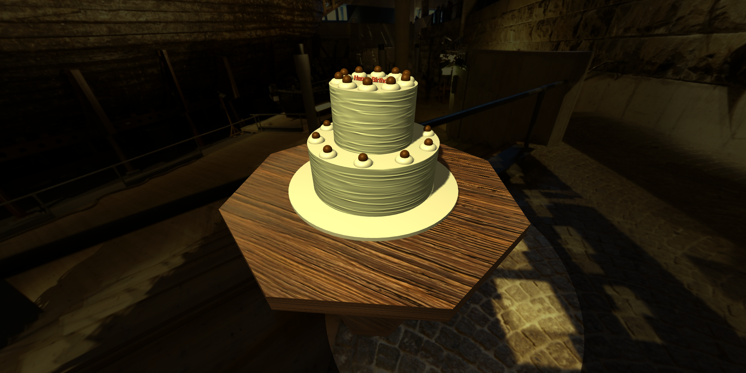

Figure 1 Viewing using Third Person Camera

* 1. **Camera Model PoV**
     1. This camera will be located at the **camera model**
     2. This camera will have the following specifications:

|  |  |
| --- | --- |
| Property | Value |
| Type | Perspective Camera |
| FoV | 75 |

* + 1. If user presses **w**, change camera view to **Third Person PoV Camera**

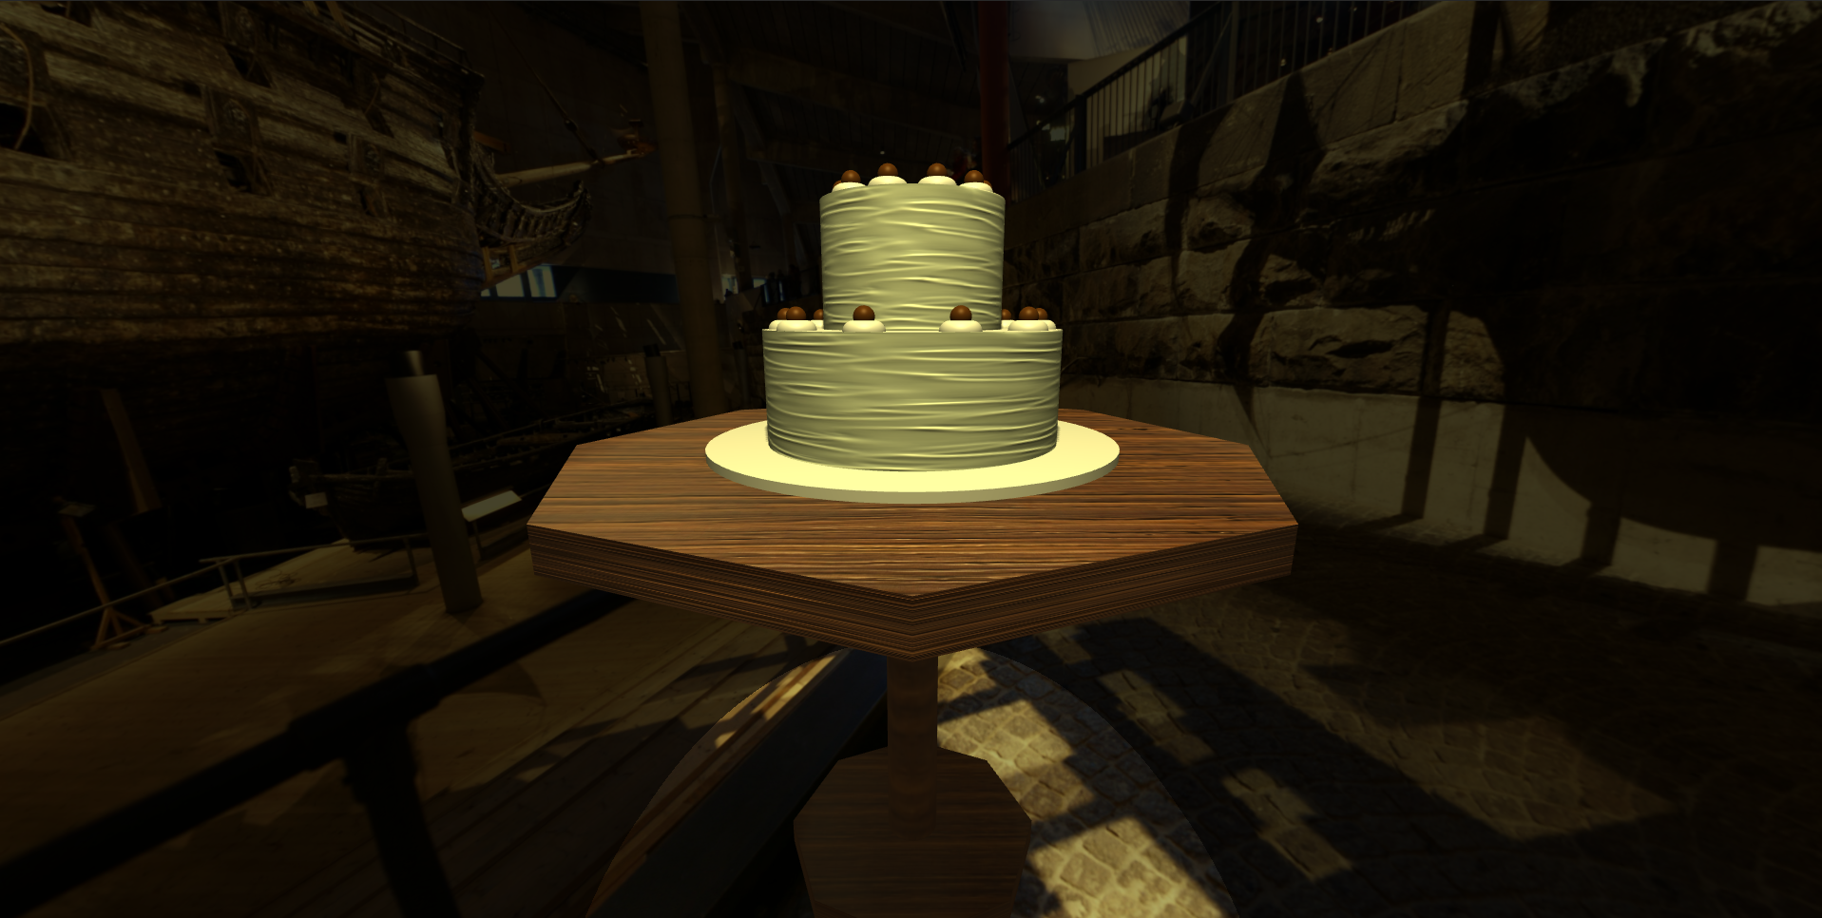

Figure Viewing using Camera Model

1. **Lighting**

There will be two global lights to illuminate the entire scene

* 1. **Ambient Light**
     1. Below are the specifications:

|  |  |
| --- | --- |
| Property | Value |
| Type | Ambient |
| Intensity | 0.3 |
| Color | #E8DC8B |

* 1. **Spotlight**
     1. The spotlight can be turned **on** and **off** if the user press **Q** key
     2. Below are the specifications

|  |  |
| --- | --- |
| Property | Value |
| Type | Spotlight |
| Intensity | 1 |
| Distance | 1000 |
| Color | #E8DC8B |
| Angle | $$π/8 rad$$ |
| Position | Vector3 (20, 30, 0) |

1. **Objects**
   1. **Table**
      1. The table consists of several parts which described as below:
         1. **Top Part**

|  |  |
| --- | --- |
| Property | Value |
| Geometry Type | Cylinder |
| Radius Top & Bottom | 12 |
| Height | 1.2 |
| Radial Segments | 8 |
| Receive Shadow | Yes |
| Cast Shadow | Yes |

* + - 1. **Leg Part**

|  |  |
| --- | --- |
| Property | Value |
| Geometry Type | Cylinder |
| Radius Top & Bottom | 1 |
| Height | 16 |
| Radial Segments | 64 |
| Position | Below Top Part |
| Receive Shadow | Yes |
| Cast Shadow | Yes |

* + - 1. **Bottom Part**

|  |  |
| --- | --- |
| Property | Value |
| Geometry Type | Cylinder |
| Radius Top & Bottom | 5 |
| Height | 1 |
| Radial Segments | 8 |
| Position | Below Leg Part |
| Receive Shadow | Yes |
| Cast Shadow | Yes |

* + 1. Each part has the following material specifications:

|  |  |
| --- | --- |
| Property | Value |
| Material Type | Mesh Phong Material |
| Texture Map |  |
| Normal Map |  |

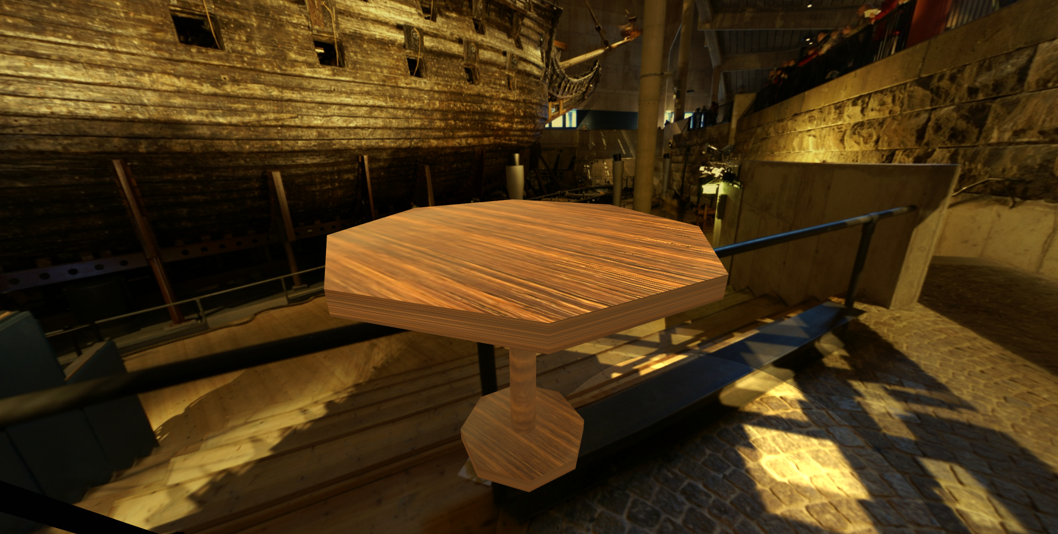

Figure Table

* 1. **Cake**
     1. Cake placed on the **top** of the **table**
     2. Cake consists of several parts:
        1. **Plate**

|  |  |
| --- | --- |
| Property | Value |
| Geometry Type | Cylinder |
| Radius Top & Bottom | 7 |
| Height | 0.5 |
| Radial Segments | 64 |
| Material Type | Mesh Phong Material |
| Receive Shadow | Yes |
| Cast Shadow | Yes |
| Reflectivity | Yes |
| Shininess | 64 |

* + - 1. **Bottom Cake**

|  |  |
| --- | --- |
| Property | Value |
| Geometry Type | Cylinder |
| Radius Top & Bottom | 5 |
| Height | 4 |
| Radial Segments | 64 |
| Position | Above the plate |
| Material Type | Mesh Phong Material |
| Receive Shadow | Yes |
| Cast Shadow | Yes |
| Side Texture Map |  |
| Side Normal Map |  |

* + - 1. **Top Cake**

|  |  |
| --- | --- |
| Property | Value |
| Geometry Type | Cylinder |
| Radius Top & Bottom | 3 |
| Height | 4 |
| Radial Segments | 64 |
| Position | Above the bottom cake |
| Material Type | Mesh Phong Material |
| Receive Shadow | Yes |
| Cast Shadow | Yes |
| Side Texture Map |  |
| Side Normal Map |  |

* + - 1. **Decoration**
         1. Decoration consists of 2 parts:

**Chocolate** **Ball**

|  |  |
| --- | --- |
| Property | Value |
| Geometry Type | Sphere |
| Radius | 0.3 |
| Width Segments | 32 |
| Height Segments | 32 |
| Position | Above the cream |
| Material Type | Mesh Phong Material |
| Receive Shadow | Yes |
| Cast Shadow | Yes |
| Color | #5E350C |

**Cream**

|  |  |
| --- | --- |
| Property | Value |
| Geometry Type | Torus |
| Radius | 0.3 |
| Tube | 0.3 |
| Radial Segments | 30 |
| Tubular Segments | 64 |
| Rotation | Euler (0, $π/ 2 rad$, 0) |
| Material Type | Mesh Phong Material |
| Receive Shadow | Yes |
| Cast Shadow | Yes |

* + - * 1. There will be **10** **decorations** placed on the **top of each cake around the edge**.
        2. Use the following formula to help place the decoration:

$x= (cake radius$– *decoration size * 2 – 0.1) * sin (n-decoration * 360 / total decoration)*

$z = (cake radius$– *decoration size * 2 – 0.1) * cos (n-decoration * 360 / total decoration)*

* + - 1. **Text**
         1. Place the text on **top** of the **top cake**.
         2. Below are the specifications:

|  |  |
| --- | --- |
| Property | Value |
| String | Happy Birthday |
| Font Type | Helvetiker Bold |
| Material Type | Mesh Standard Material |
| Rotation | Euler ($- π/ 8 rad$, $π/ 2 rad$, 0) |
| Color | #D65645 |
| Cast Shadow | Yes |
| Receive Shadow | Yes |

* + 1. Cake can be **interacted** by pressing specific keys on keyboard:
       1. If user presses **D** key, **rotate** the entire cake **clockwise** by $π/ 200 rad$ every render loop
       2. If user presses **A** key, **rotate** the entire cake **counterclockwise** by $π/ 200 rad$ every render loop
       3. If user presses **Space** key, **reset** the rotation.

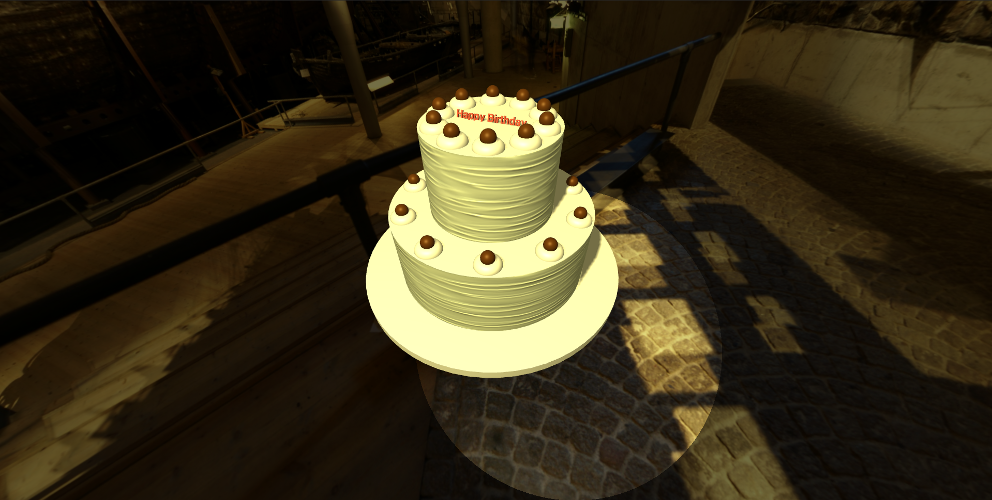

Figure 4 Birthday Cake

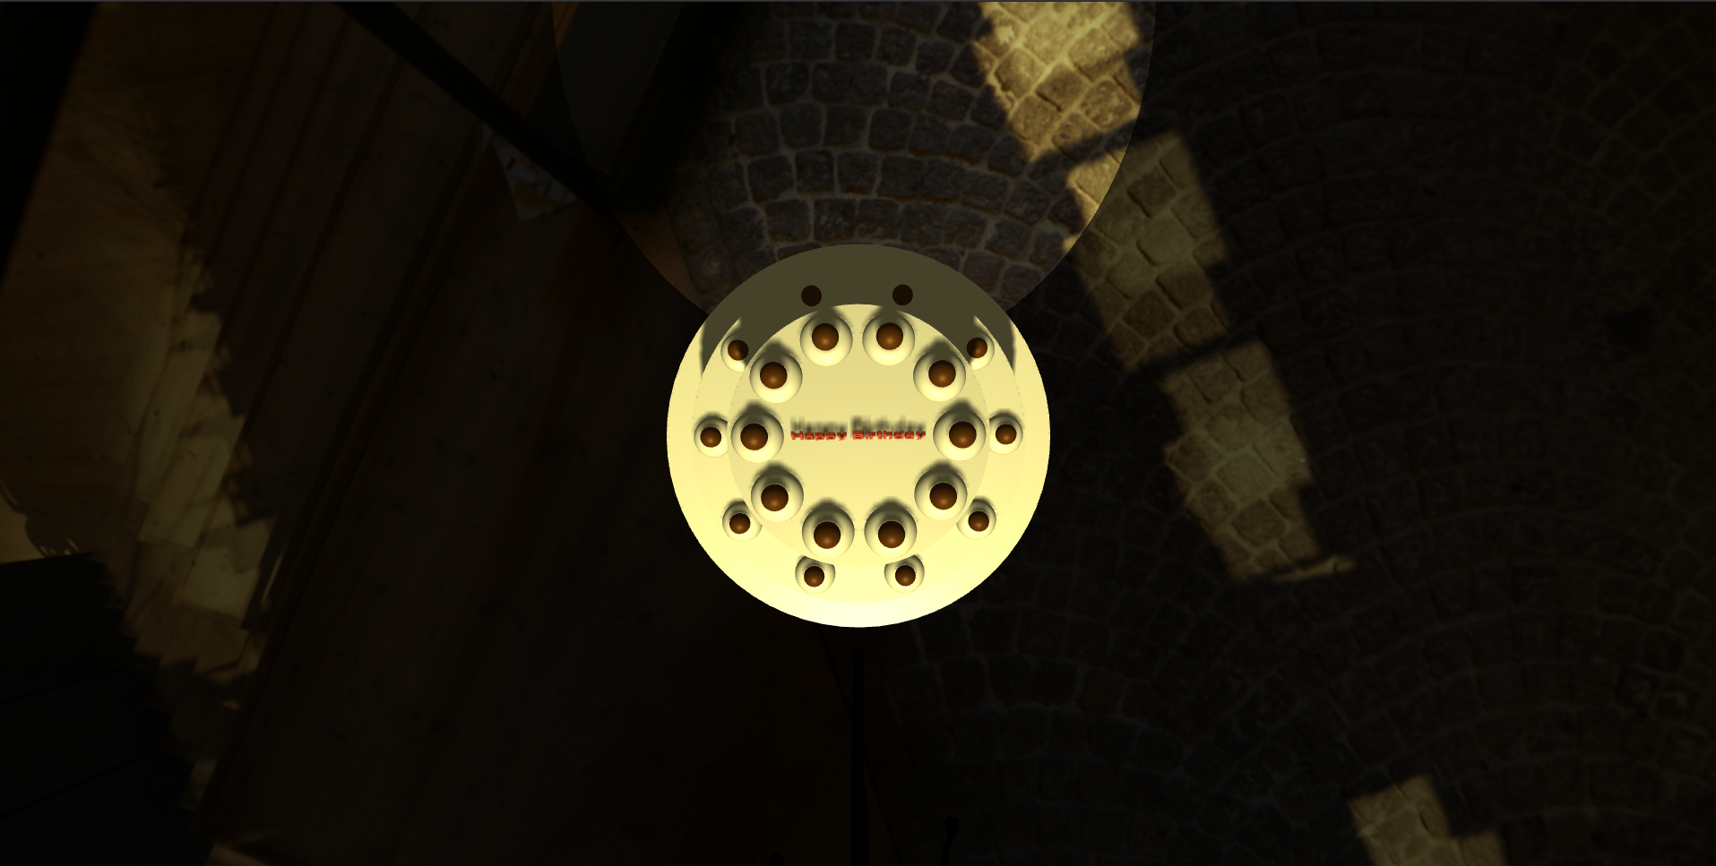

Figure 5 Birthday Cake Top View

* 1. **Candle**
     1. Candle can be added manually by **clicking** on the **top** of the **top cake up to 5 candles** using **Raycast** concept. It will be located where the **intersecting point** of the Raycast.
     2. The candle can only be added if the cake **rotation** is at **0 rad** either rotate the cake manually or reset its rotation.
     3. The candle consists of 2 part:
        1. **Top Part**

|  |  |
| --- | --- |
| Property | Value |
| Geometry Type | Cone |
| Radius | 0.05 |
| Height | 0.1 |
| Radial Segments | 64 |
| Position | Above Body Part |
| Material Type | Mesh Phong Material |
| Receive Shadow | Yes |
| Cast Shadow | Yes |
| Texture Map |  |

* + - 1. **Body Part**

|  |  |
| --- | --- |
| Property | Value |
| Geometry Type | Cylinder |
| Radius | 0.05 |
| Height | 0.5 |
| Radial Segments | 64 |
| Material Type | Mesh Phong Material |
| Receive Shadow | Yes |
| Cast Shadow | Yes |
| Texture Map |  |

* + 1. Each candle will emit light towards its surrounding, below are the light specifications:

|  |  |
| --- | --- |
| Property | Value |
| Type | Point Light |
| Color | #E65C2C |
| Intensity | 1 |
| Distance | 8 |
| Position | At the top of Top Part |

* + 1. The candle can be switch **on** and **off** by pressing **S** key

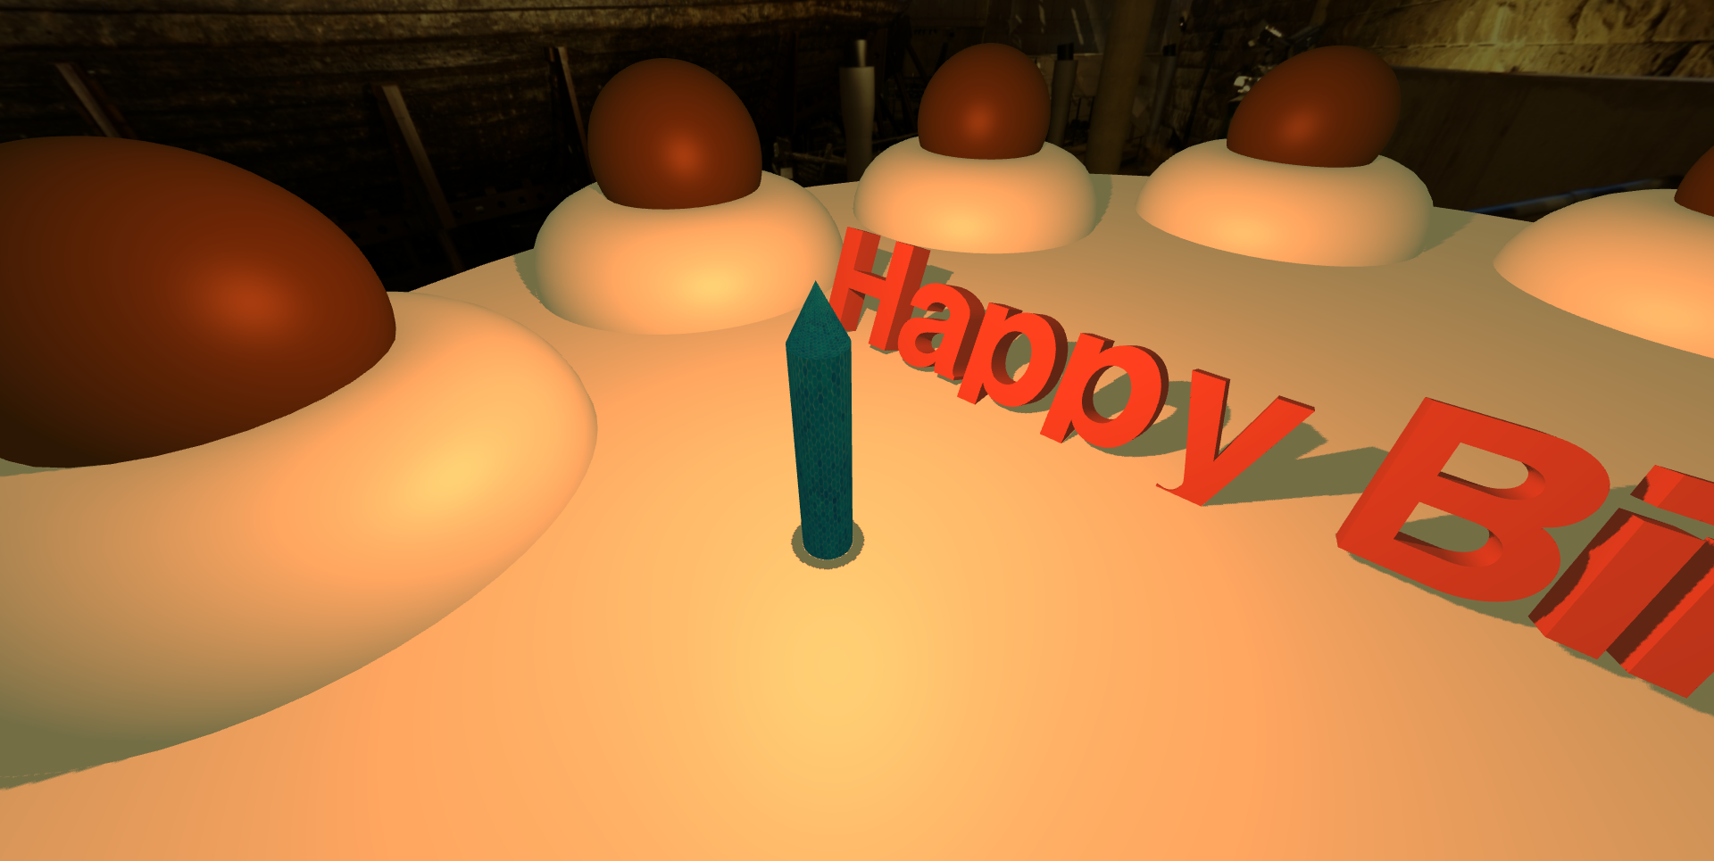

Figure 6 Candle with Light

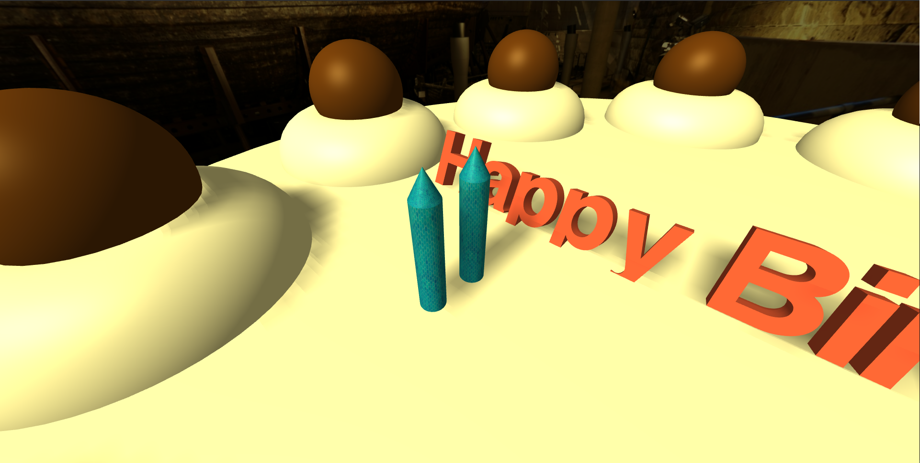

Figure 7 Candle without Light

* 1. **Camera Model**
* Load model from the **GLTF** **file** **“**model.gltf**”**
* When first load the model’s **size** and **orientation** is not the most optimal, so you need to **adjust** it yourself
* Below are the specifications

|  |  |
| --- | --- |
| Property | Value |
| Position | Vector3 (20, -2, 0) |
| Rotation | Euler (0, $- π/ 2 rad$, 0) |

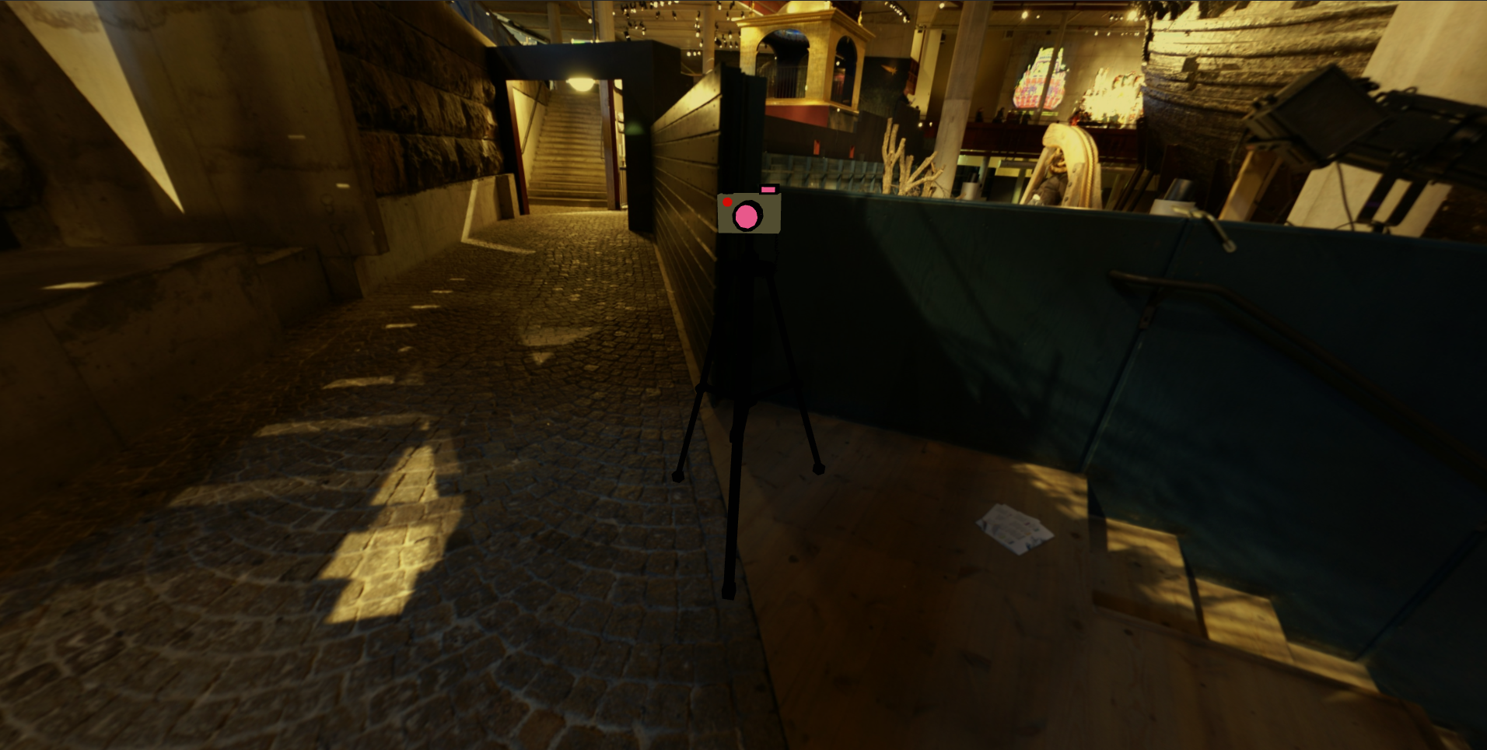

Figure 8 Camera Model

1. **Skybox**

Create the skybox using **cube mapping technique** with the following specifications:

|  |  |
| --- | --- |
| Property | Value |
| Size | 500 x 500 x 500 |
| Material | Mesh Phong Material |
| Texture  (in sequence: px, nx, py, ny, pz, nz) | Sebuah gambar berisi malam  Deskripsi dibuat secara otomatis Sebuah gambar berisi platform, malam  Deskripsi dibuat secara otomatis Sebuah gambar berisi tempat lilin, berjajar  Deskripsi dibuat secara otomatisSebuah gambar berisi lantai, dalam ruangan  Deskripsi dibuat secara otomatis Sebuah gambar berisi beberapa  Deskripsi dibuat secara otomatis Sebuah gambar berisi dalam ruangan, lantai, beberapa  Deskripsi dibuat secara otomatis |

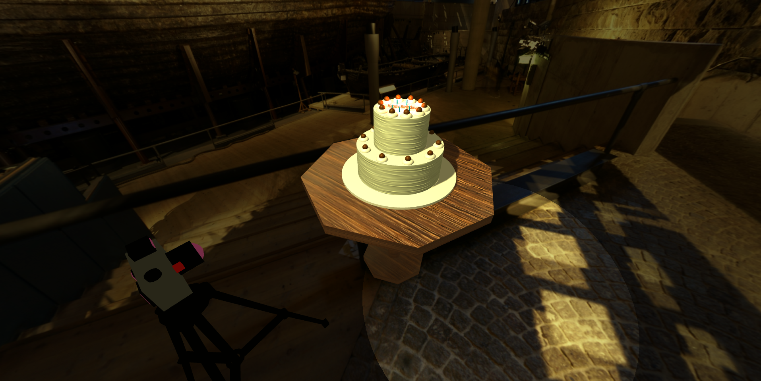

Figure Final Result

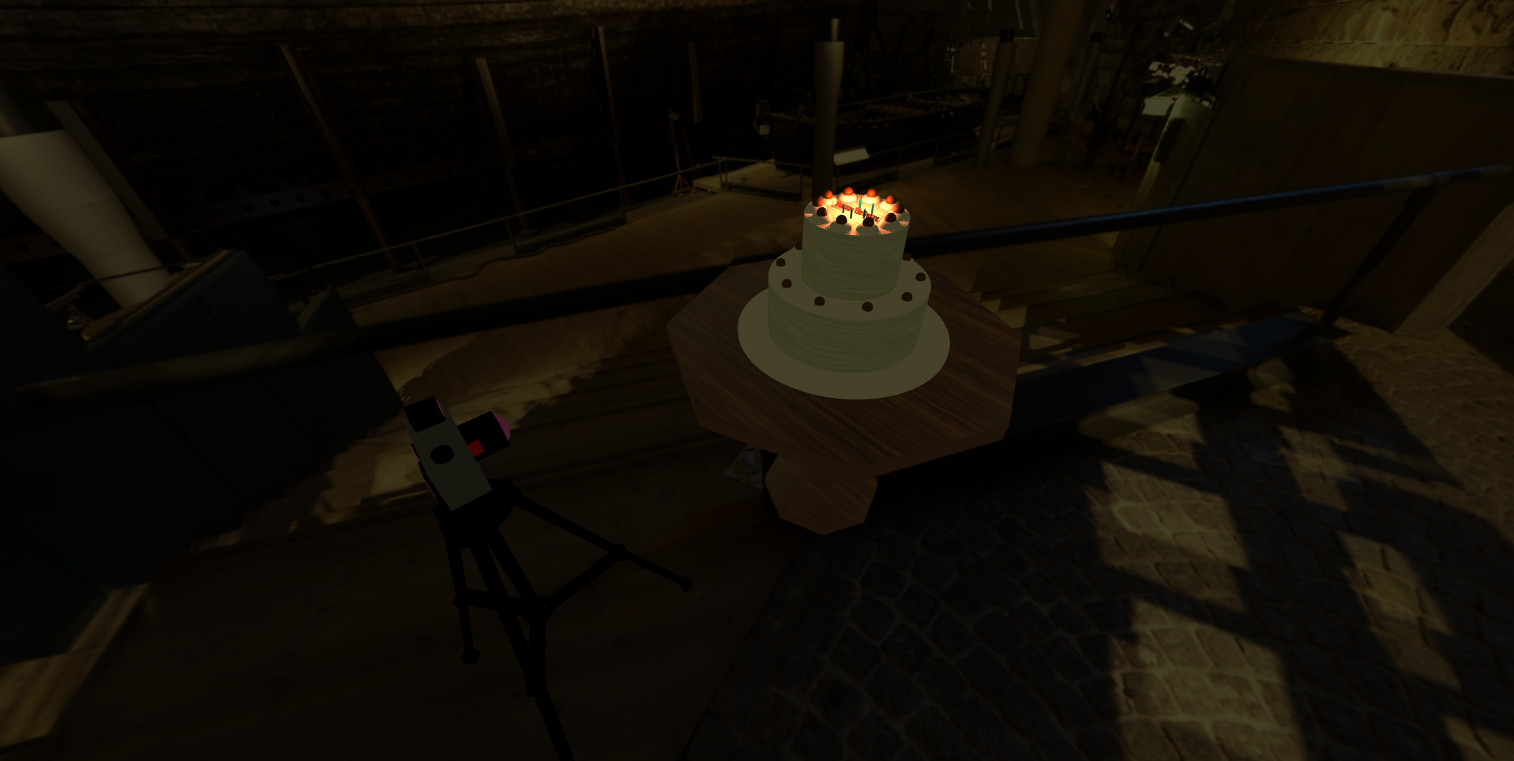

Figure 10 Final Result with Candlelight

Here are the rules that you must follow to create your project:

1. Use appropriate software for this subject based on **Sistem Praktikum** that can be downloaded from Binusmaya
2. Use the techniques taught during practicum.
3. Collect appropriate files for this subject based on **Sistem Praktikum** that can be downloaded from Binusmaya
4. Include the other files that can support your project, such as:
   * All files in your project
   * Other files (image, audio, video, etc.) used in your project
   * *.DOC file (documentation of your project) that contains all pages in your project, reference links of additional files (image, audio, video, etc.) used in your project, the description about how to use your application, etc

**References**

https://poly.google.com/view/5CHQvf_emuN

https://opengameart.org/content/indoors-skyboxes

http://www.humus.name

http://bgfons.com/download/3178

https://line.17qq.com/articles/qhsgpqkky_p6.html

https://freestocktextures.com/photos-blue/?page=2